USER GUIDE

What to do…

all files together

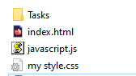

each task will have its own folder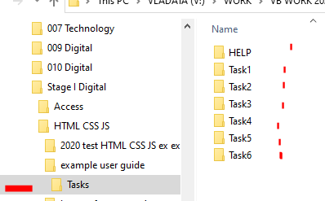

the look when you open the index file

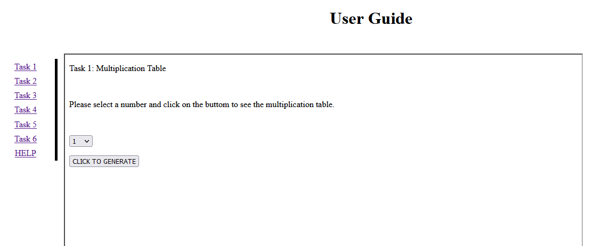

Task 1 is about multiplication. Choose the number and then show the timetables. You need a for loop here.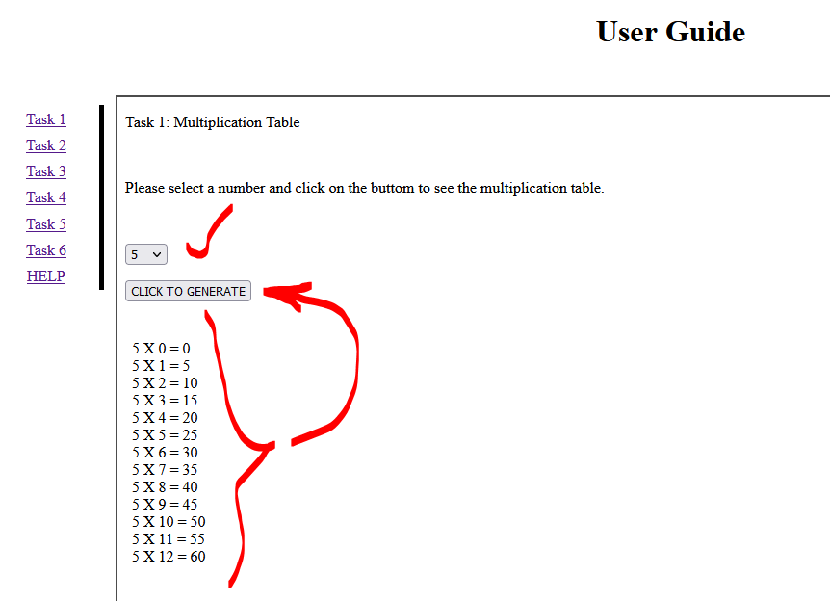

Task 2 it is all about APIs for different objects. 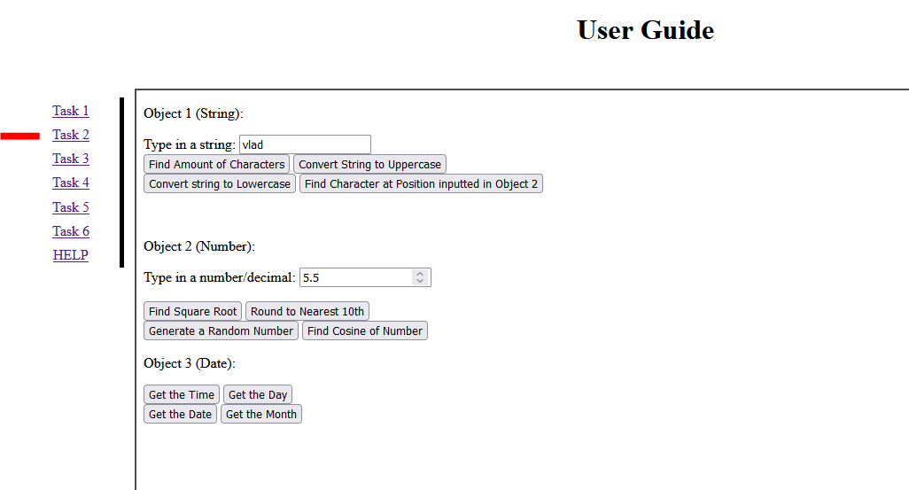

Task 3 it is about random number generator. You create a hypothetical dice with as many sides you want.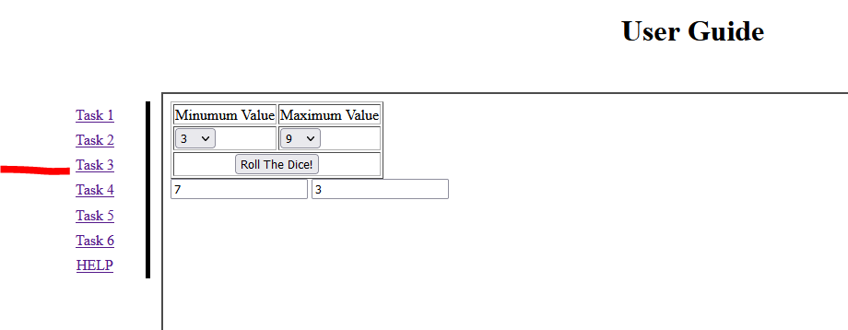

Task 4 is about the use of cookies (complex task). You can also investigate “data storage” or web storage

Check here: <https://www.w3schools.com/html/html5_webstorage.asp>

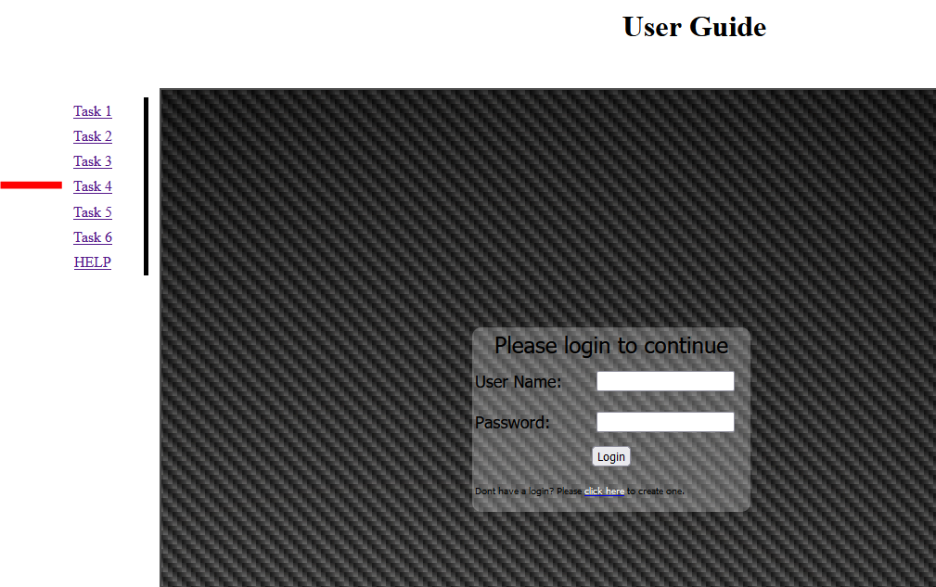

Task 5 is using the modulo operator and your knowledge of organising the layout properly

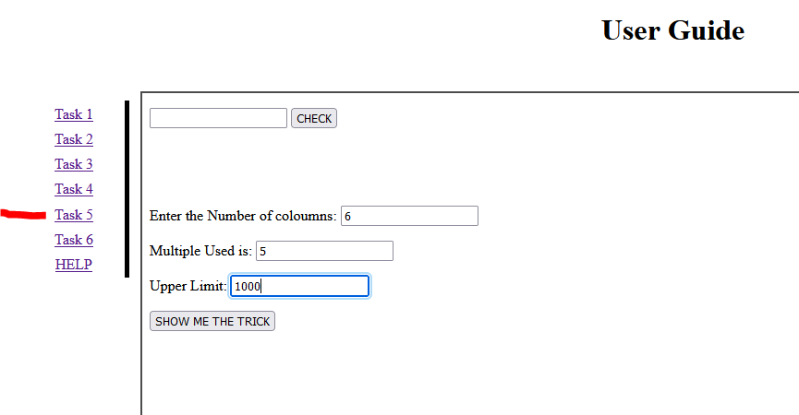

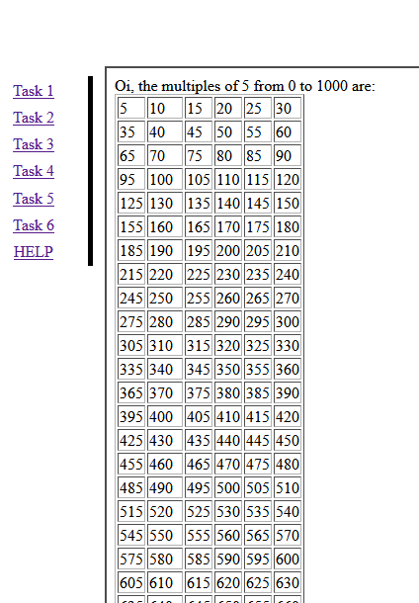

Task 6 Is about populating some input when some other inputs are chosen.

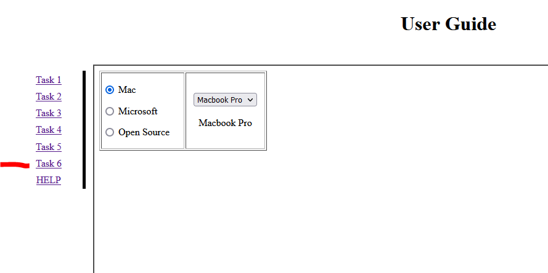

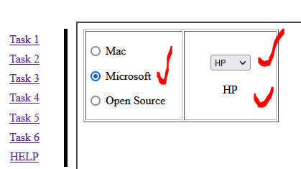

Task HELP is very easy, is just to embed some lectures into the website. 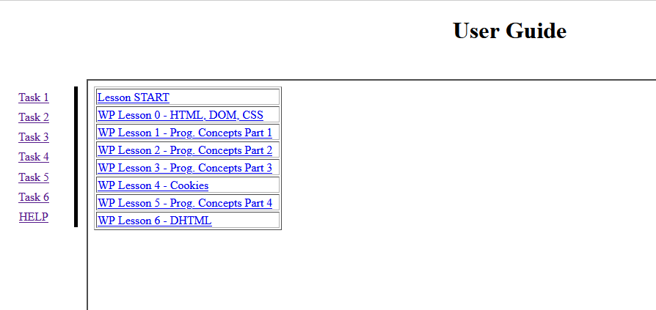

A video will be done shortly…